David Hudson

It-2030

Lab 12

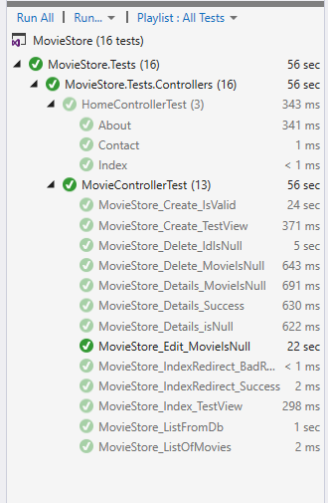

When I tried to run Edit_IdIsNull and put in the parameter of null when passing it in the Act phase, it told me that it was ambiguous and I should just use the delete line, unallowing me to build it. I wasn’t able to figure out a way to pass null through as the parameter despite it allowing it with it accepting int? as an input.

